 

**Course: Technion Certified Data Scientist**

**Final Project Report**



**Class TCDS-12**

**Submitted: 21/01/20**

Table of Contents

**1.** **Introduction** 4

**1.1. Data Summary** 4

**1.1.1. Overview** 4

**1.1.2. Project goal** 4

**2.** **Descriptive Statistics** 5

**2.1. Movies** 5

**2.1.1. Movies by Release Years** 5

**2.1.2. Movies by Genre** 5

**2.2. Users** 6

**2.2.1. Users by Gender** 6

**2.2.2. Users by Age** 6

**2.2.3. Users by Occupation** 7

**2.3. Ratings** 7

**2.3.1. Ratings Histogram** 7

**2.3.2. Ratings Boxplot (Describe)** 8

**2.3.3. Ratings per Genre – Frequency Table** 8

**2.3.4. Average Ratings per Genre** 9

**2.3.5. Ratings per movie / per user** 10

**3.** **Extraction of 'Valuable' Data** 11

**3.1. Understanding Relationships between Entities** 11

**3.2. 'Valuable' Data Tradeoff** 11

**3.3. 'Valuable' Data Selection** 11

**3.3.1. Identifying the 'Threshold' Value for 'Valuable' Data** 12

**3.3.2. 'Valuable' Data Exploration** 13

**3.4. Conclusion:** 14

**4.** **Model Selection & Evaluation** 15

**4.1. Recommendation System Paradigms** 15

**4.2. Collaborative Filtering** 16

**4.2.1. Collaborative Filtering Model Selection Process** 16

**4.2.2. Conclusion** 16

**4.2.3. 'Hit Rate' Performance Measure** 17

**4.2.4. 'Collaborative Filtering' Best Model Selection** 17

**4.2.5. Exploring 'Best Model' with Selected Dataset** 18

**4.3. Content-Based Filtering** 19

**4.3.1. Content-Based filtering principles** 19

**4.3.2. Data Preparation** 20

**4.3.3. Finding similarity between items** 20

**4.3.4. Results** 21

**4.3.5. Conclusions** 21

**4.4. Model Limitations & Mitigations** 22

**4.4.1. Model Weaknesses & Limitations** 22

**4.4.2. Mitigations to Model Weaknesses & Limitations** 22

**5.** **Conclusions** 23

**5.1. The main conclusions from the project described above are as follows:** 23

**6.** **Future Work** 24

**7.** **Appendices** 25

Appendix 1 25

# **Introduction**

## **Data Summary**

### **Overview**

The 'Movielens' Dataset consists of the following:

* 100,000 ratings (1-5) from 943 users on 1682 movies (including timestamps of ratings).
* Basic demographic information for each user (age, gender, occupation, zip).
* Basic information for each movie (title, release date, IMDb url, Genres).

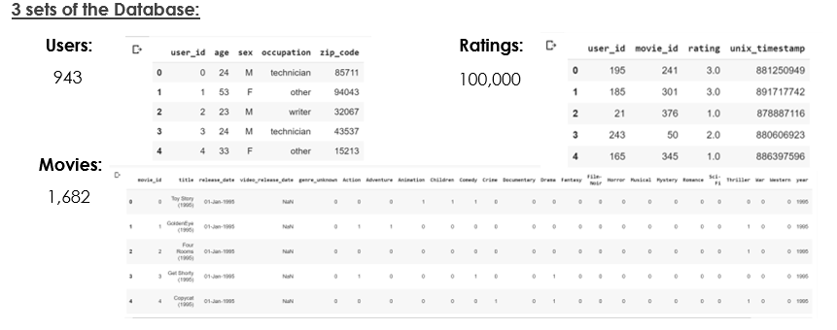

The data has been cleaned up. Users who had less than 20 ratings or did not have complete demographic information were removed from this data set.

The data was collected through the MovieLens Website (movielens.umn.edu) during the seven-month period from September 19th, 1997 through April 22nd, 1998.

The MovieLens Website belongs to the GroupLens RESEARCH PROJECT, which is a research group in the Department of Computer Science and Engineering at the University of Minnesota. Members of the GroupLens Research Project are involved in many research projects related to the fields of information filtering, collaborative filtering, and recommender systems.

### **Project goal**

**Recommend the 10 most relevant movies to each user**

# **Descriptive Statistics**

Below are Descriptive Statistics of each part of the Dataset – Movies, Users & Ratings.



## **Movies**

### **Movies by Release Years**

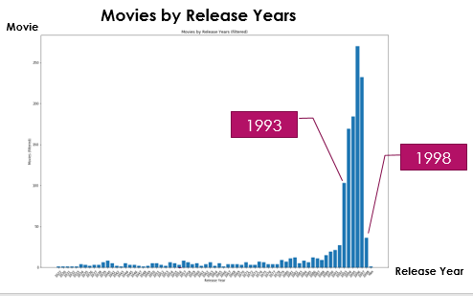

It can be seen that the majority of the movies were released between the years 1993-1997

### **Movies by Genre**

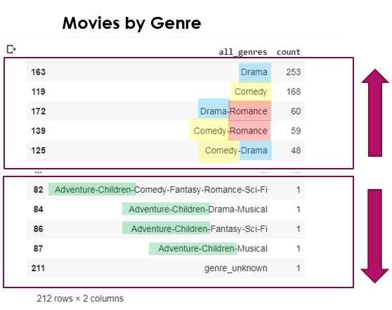

Most movies were classified as 'Drama' or 'Comedy' (or both), or as a combinations of each ('Drama' or 'Comedy') with 'Romance'

## **Users**

### **Users by Gender**

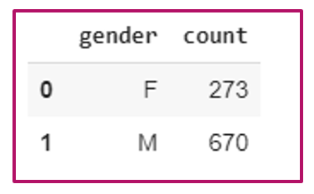

The users consist of 273 Females and 670 Males, means the gender parameter is unbalanced.

### **Users by Age**

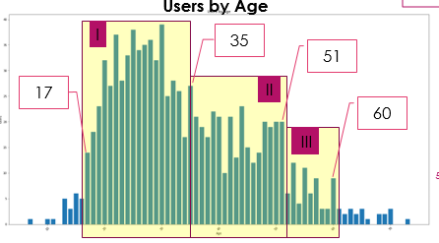

The users can roughly be divided into 3 age groups:

* Ages 17-35 – Biggest group
* Ages 36-51 – Medium group
* Ages 52-60 – Smallest group

### **Users by Occupation**

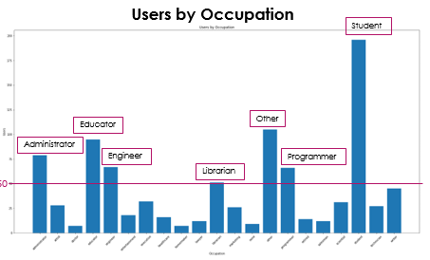

The most popular occupations among the users are as follows:

Student, Educator, Administrator, Engineer, Programmer, Librarian or 'Other'.

## **Ratings**

### **Ratings Histogram**

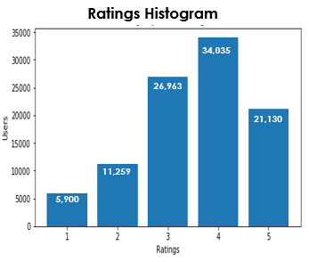

The most frequent rating is 4, then 3, the 5. Meaning, most movies were rated at the 'high-end' of the scale.

### **Ratings Boxplot (Describe)**

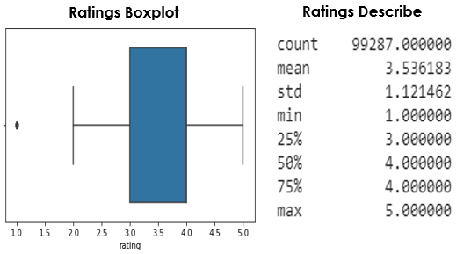

Most movies were rated at the 'high-end' of the scale, the mean (3.53) and the median (4) of the Ratings are above the middle of the scale (2.5=5/2).

### **Ratings per Genre – Frequency Table**

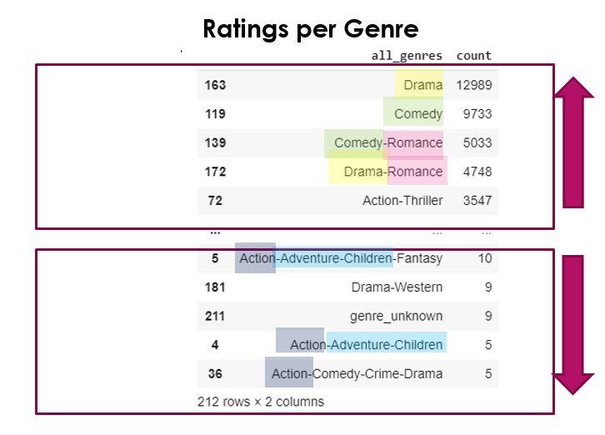

Movies which received MOST ratings are from 'Drama' or 'Comedy' (or both), or as a combinations of each ('Drama' or 'Comedy') with 'Romance'. As seen above, these are also the most common genres in the dataset.

Movies which received LEAST ratings are from 'Action' or 'Children-Adventure'. As seen above, 'Children-Adventure' is also among the least common genres in the dataset.

The following is a distribution of the ratings among all genres and combinations (total of 212):

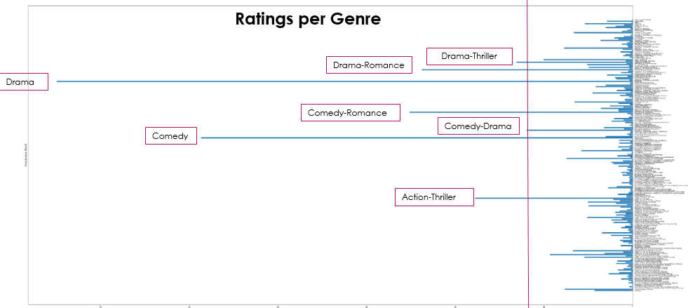

After 'Drama' / 'Comedy' and combinations (with 'Romance' and each other), 'Thrillers' (of types 'Drama' and 'Action) received the high ratings.

### **Average Ratings per Genre**

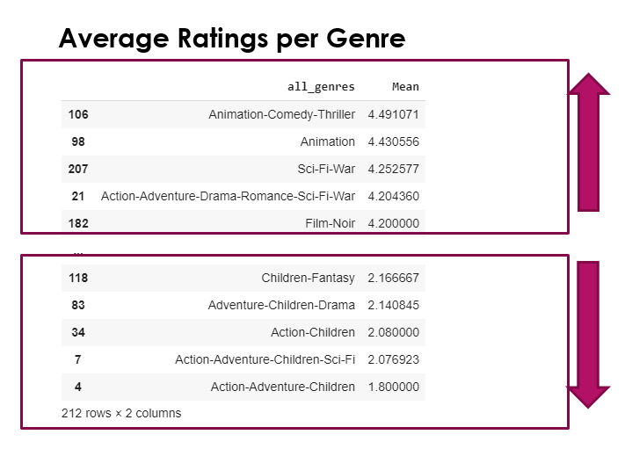

Movies that received the HIGHEST average ratings (4.2 and above) are of the following genres:

* Animation-Comedy-Thriller, Animation, Sci-Fi-War, Action-Adventure-Drama-Romance-Sci-Fi-War, Film Noir.
* These are different genres than the most popular / most rated in the dataset. Meaning, **the Average Rating may not be directly correlated to the Movie's Distribution / Popularity.**

Movies that received the LOWEST average ratings (2.17 and below) are of the following genres:

* Children-Fantasy, Adventure-Children-Drama, Action-Children, Action-Adventure-Children-Sci-Fi, Action-Adventure-Children. These are similar genres to the least popular / rated in the dataset.
* In this case, **the Average Rating seems directly correlated to the Movie's Distribution / Popularity.**

### **Ratings per movie / per user**

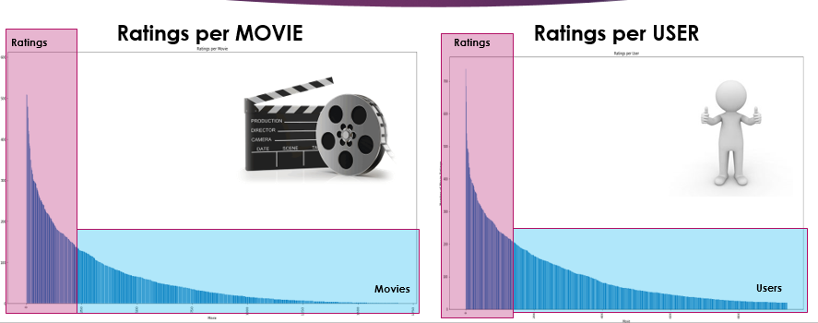

Both the 'Number of Ratings for Each Movie' and the 'Number of Ratings for Each User' have a 'Long-Tail' distribution.

# **Extraction of 'Valuable' Data**

This chapter describes the process of identifying the 'Valuable Data' to be used by the model.



## **Understanding Relationships between Entities**

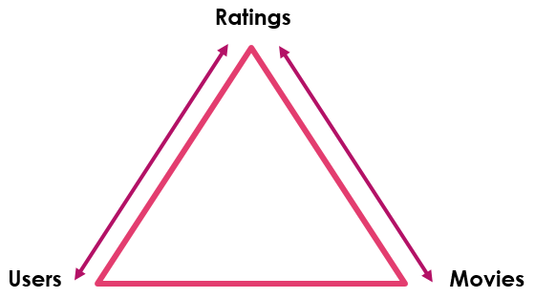

The 'Ratings' data includes information from both 'Movies' (movie-rating) and from 'Users' (user-rating). Therefore, filtering 'Rating' data should be done very carefully, without unintentional harming of 'Movies' or 'Users' data.

## **'Valuable' Data Tradeoff**

When we tried to filter the data in order to obtain the 'high-quality' portion of it (movies / users with sufficient ratings), the following trade-offs arise:

* **Data Integrity vs. Long-Tail Leverage** - Data Integrity may be higher as approaching the 'Head' of the distribution, however by filtering only that part of the data the less opportunities are left to leverage the 'Long Tail'.
* **'User Ratings' vs. 'Niche Movie Ratings'** – Filtering out 'Niche Movie Ratings' will also filter out some 'User Ratings' (of users who rated that movie). 'User Ratings' are important information (as they define the user), and therefore the aim is to keep as many of them as possible.

The 'Valuable' data shall be obtained while trying to find the right balance between these trade-offs.

## **'Valuable' Data Selection**

Ratings / Movies Frequency Table

The first step in identifying the 'Valuable' data was creating the following frequency table:

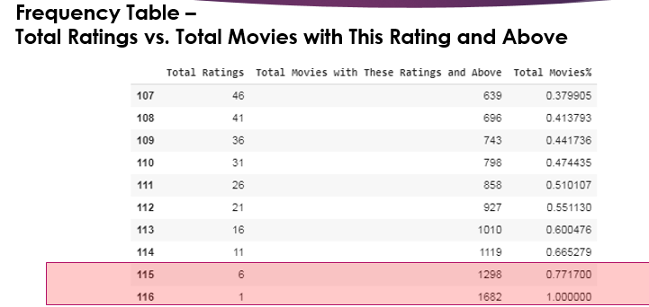

This table displays the Frequency of Movie Ratings.

For example, according to row 116, all 1682 movies have 1 rating and above. According to row 115, only 1298 of the movies have 6 ratings and above, and so forth.

The table above enables to see the quantitive Effect of 'filtering movies with insufficient ratings' on the 'overall movie population' in the dataset.

### **Identifying the 'Threshold' Value for 'Valuable' Data**

Defining a 'Threshold' of 'Rating >=5' (meaning movies with less than 5 ratings will be filtered out), 'Valuable Data' will be as follows:

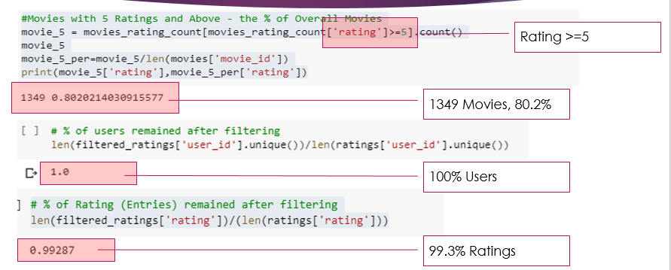

### **'Valuable' Data Exploration**

Below is a guided exploration of the 'Valuable' (filtered) data, focused on identifying its differences from the 'Complete' (Non-Filtered) Data.

* Movies by Release Years

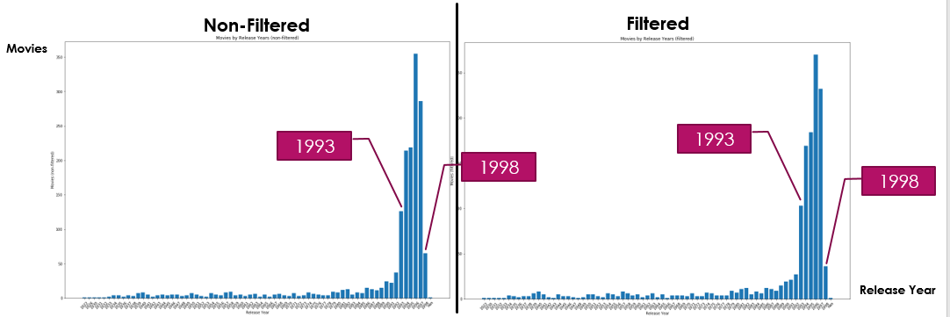

The 'Movies by Release Years' distribution is very similar in both 'Non-Filtered' and 'Filtered' data

* Movies by Genre

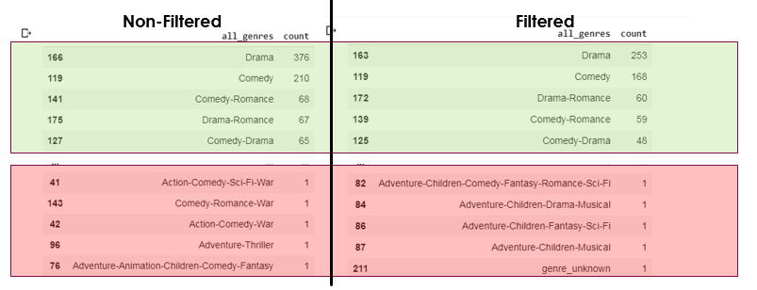

The 'Movies by Genre' distribution on its 'head' part is very similar in both 'Non-Filtered' and 'Filtered' data.

* Ratings

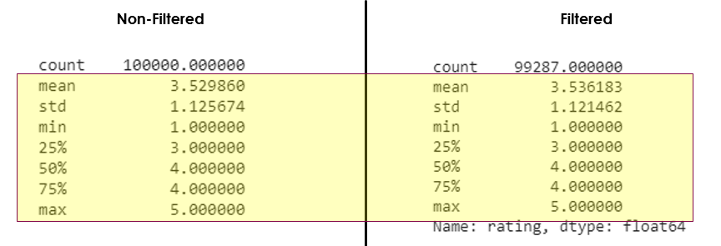

The 'Ratings' distribution is very similar in both 'Non-Filtered' and 'Filtered' data

## **Conclusion:**

'Valuable Data' (with sufficient 'Tail' for leveraging) can be initially defined as 'Movies with 5 Ratings and above', as follows:

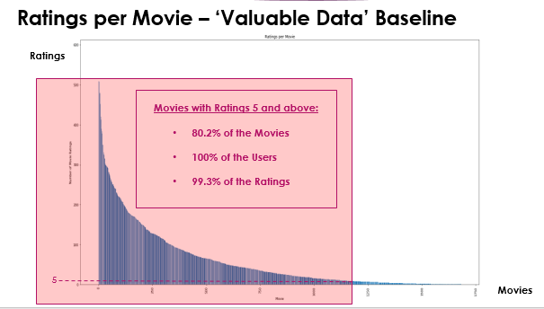

# **Model Selection & Evaluation**



## **Recommendation System Paradigms**

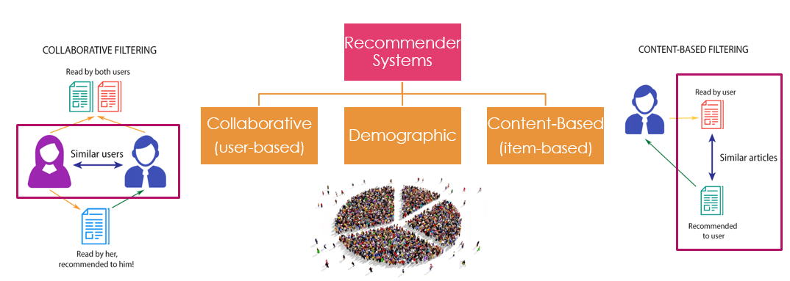

There are 4 main System Paradigms for Recommendation Systems:

**Collaborative** – based on identifying similar users according to (their) similar ratings (preferences).

**Content-Based** – identifying similar items based on their content.

**Demographic** – identifying similar users according to Demographic Segmentation.

**Knowledge-Based** – using Machine and Deep learning to collect data and identify the user needs.

In this project, 'Collaborative' and 'Content Based' System Paradigms will be used to generate recommendations.

## **Collaborative Filtering**

### **Collaborative Filtering Model Selection Process**

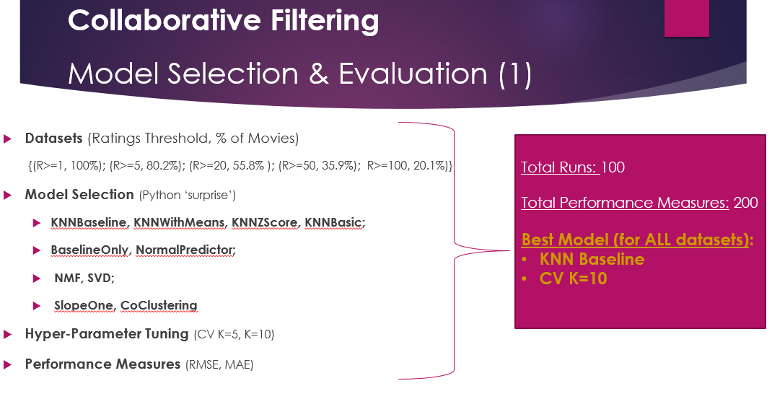

The collaborative model selection was done as described above, using:

* 5 different datasets
* 10 different models (from Python 'Surprise' package)
* 2 versions of each model (with different Cross Validation Parameter K)
* 2 Performance Measures

In total:

* 100 runs were made (5*10*2)
* 200 Performance Measures were obtained

For outputs of all runs – see Appendix 1

### **Conclusion**

As can be seen from outputs, the 'KNN Baseline' Model with 'CV K=10' was proven unanimously (in all runs) as producing the least RMSE / MAE. Therefore, it was selected as the best-fitted model for the data.

### **'Hit Rate' Performance Measure**

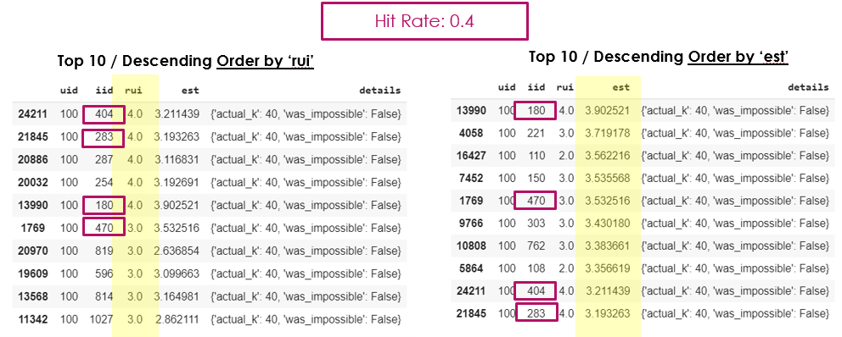

The 'Hit Rate' Performance Measure was created specifically for this project's goal of measuring the quality of the 'Top 10' List generated by the model.

This performance Measure compares the 'Top-10 Movies according to Actual Rating' list with the 'Top-10 Movies Recommended by the Model' list, and defines the ratio of movies both lists have in common.

In the above example, the two lists have 4 measures in common, therefore Hit Rate is 0.4 (4/10).

### **'Collaborative Filtering' Best Model Selection**

* 'Best Model' with Different Datasets

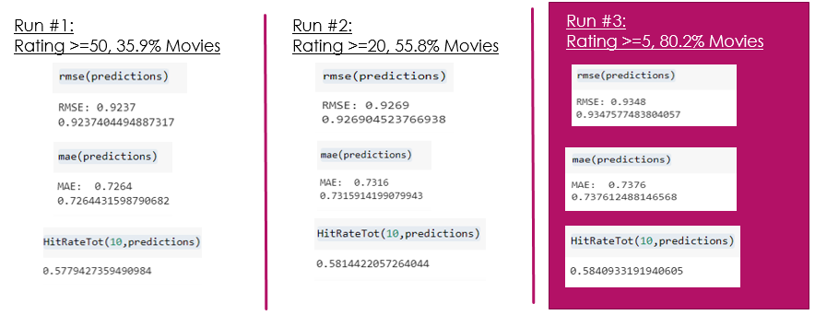

To further explore the selected model, above is a comparison of its Generated Results with 3 different datasets (Ratings >=50, >=20,>=5, as these are the 3 datasets from the 'Middle of the Scale' which are more likely to produce non-eccentric results).

Results are similar in all runs.

It was our decision to proceed with the Rating >=5 Dataset, which highly resembles the 'Non-Filtered' Dataset, as well as maintains the most 'Long Tail' items (and the most Leveraging Opportunities).

### **Exploring 'Best Model' with Selected Dataset**

* **Selected Dataset's 'Predicted Vs. Actual'**

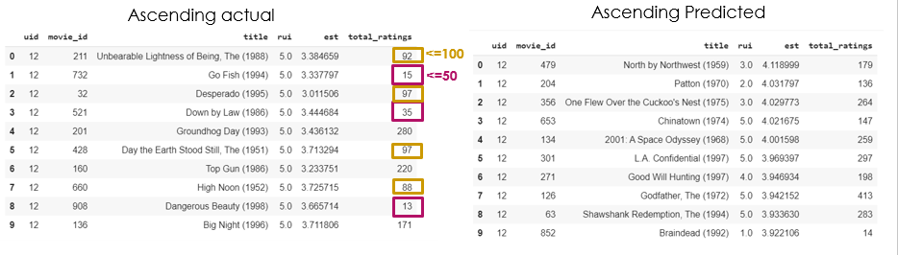

Above is an example of user_id=12, who gave a 5.0 (maximal) Actual Rating to movies which were rated by relatively 'few' users (13, 15, 35). This is a demonstration of how 'long tail' items may contain significant information, and why keeping movies in the 'Long Tail' is important.

* **'Predictions' of Selected Dataset vs. Dataset with Ratings Threshold>=50**

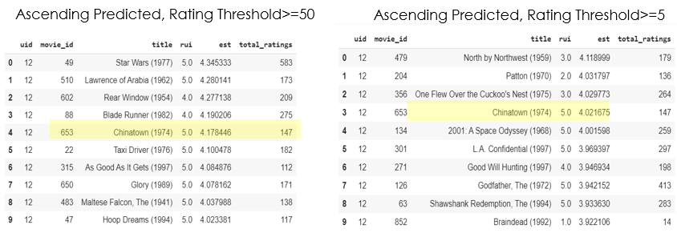

Above is an example of the different 'Top 10' Recommendations Lists produced by the same model with different input data (Rating >=5 and Rating >=50). The lists are significantly different, with only 1 movie in common! This demonstrates the extent of differences in the outputs resulting only from different input data.

## **Content-Based Filtering**

### **Content-Based filtering principles**

Content-based filtering is one of the common methods in building recommendation systems. There are two approaches that can be considered as content based system:

* **Analyzing description of the content only.**
* **Building user profile and item profile from user rated content.**

The first approach is similar to item based collaborative filtering which means the system will recommend anything similar to an item you like before.

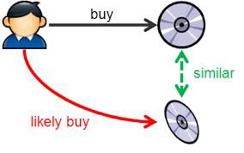

In model-building stage, the system first find the similarity between all pairs of items (where items can be – columns of a table, words in metadata or sentence etc.), then it uses the most similar items to a user’s already-rated items to generate a list of recommendations in recommendation stage.

The second approach leverages description or attributes from items the user has interacted to recommend similar items. It depends only on the user previous choices, making this method robust to avoid the cold-start problem. Suppose user watch a particular genre movie, he will be recommended movies with respective to that specific genre. The Title, Year of Release, Director and Cast are also helpful in identifying similar movie content.

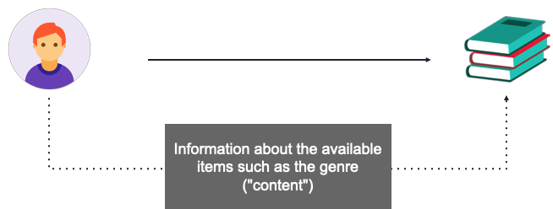

### 

### **Data Preparation**

For using a content based filtering method we tried to collect additional data that will help the system to find similar movies based on features like:

* Production Company
* 5 top actors
* Director/s
* Writer/s
* Producer/s
* Composer/s

The assumption is that: if user rated a movie with 5.0, let’s say, Aladdin, he will probably also like ‘Lion King’, ‘Jungle Book’, ‘Toy Story’ – movies from Disney, and/or picture-motion movies and/or children movies.

With this assumption we build a metadata vector of each movie contains the above features and the genres.

We tried to extract these features using IMDBpy library but we got a lot of exceptions. We search the features based on the movies names, but the search engine accepts only the exact movie name, else it returns empty vector of wrong movie.

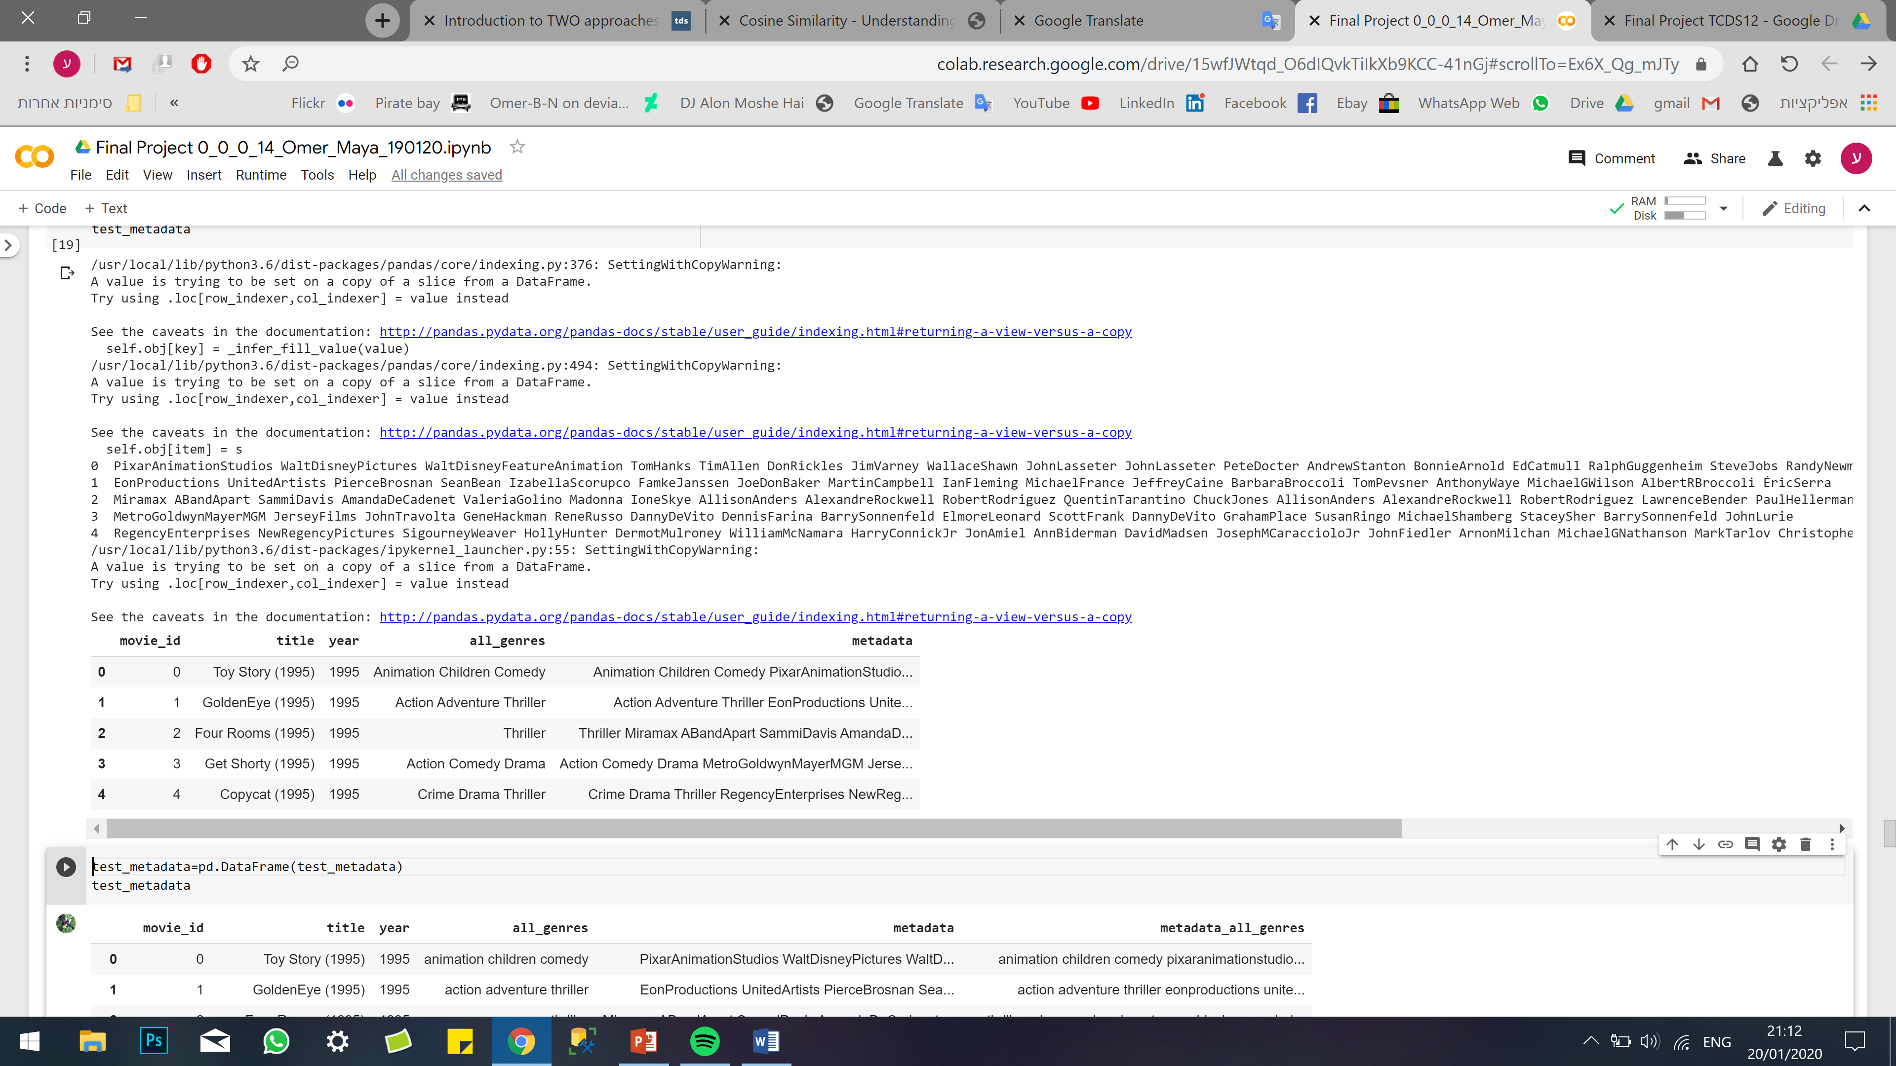

We managed to collect data of for almost all movies after a lot of running attempts. And we used this data for the system.

We also compered the results for movies with only genres metadata to movies with full enhanced metadata.

### **Finding similarity between items**

There are several method to find similarity grade between two different items:

* Cosine Similarity
* Euclidean Distance
* Peason’s Correlation

After we searched for the right method we decided to use Cosine Similarity.

Cosine similarity is a metric used to determine how similar the documents are irrespective of their size. Mathematically, it measures the cosine of the angle between two vectors projected in a multi-dimensional space.

In our system, every word in the metadata is an item which means every word is a dimension.

The cosine similarity function calculate the angle between the words in the reference movie’s metadata and the word of each movie metadata. Higher the result – Higher the similarity.

### **Results**

* USER ID 286 rated ‘Toy Story’ as 5.0. the movies the system recommended from **240 movies** were:

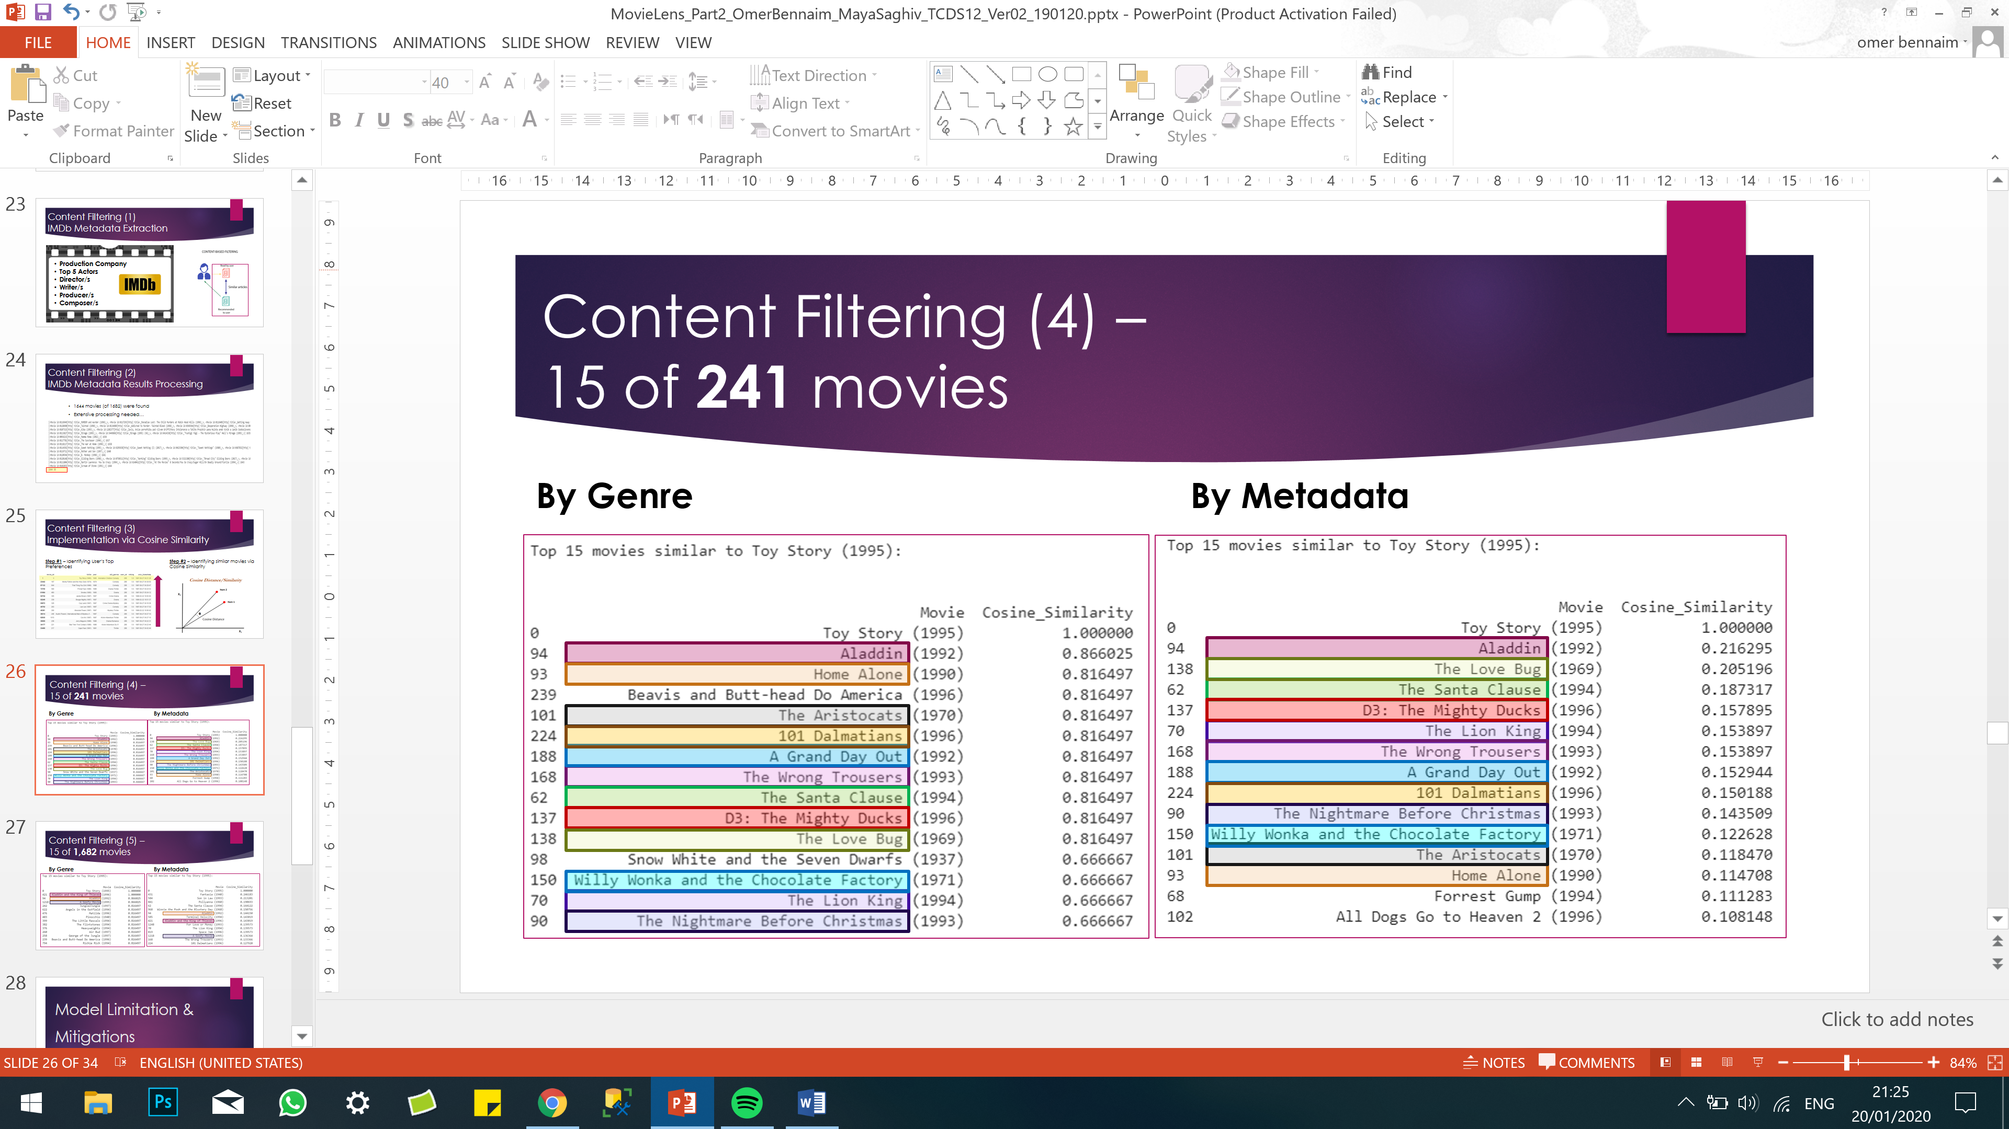

Although we can notice that there is almost no difference between the lists. We can notice a difference between the lines. ‘Beavis and butt-head do America’ fade out from the right list because it is not a Disney movie, and Tim Allen or Tom Hanks are not playing in this movie.

* The movies the system recommended from **all movies** were:

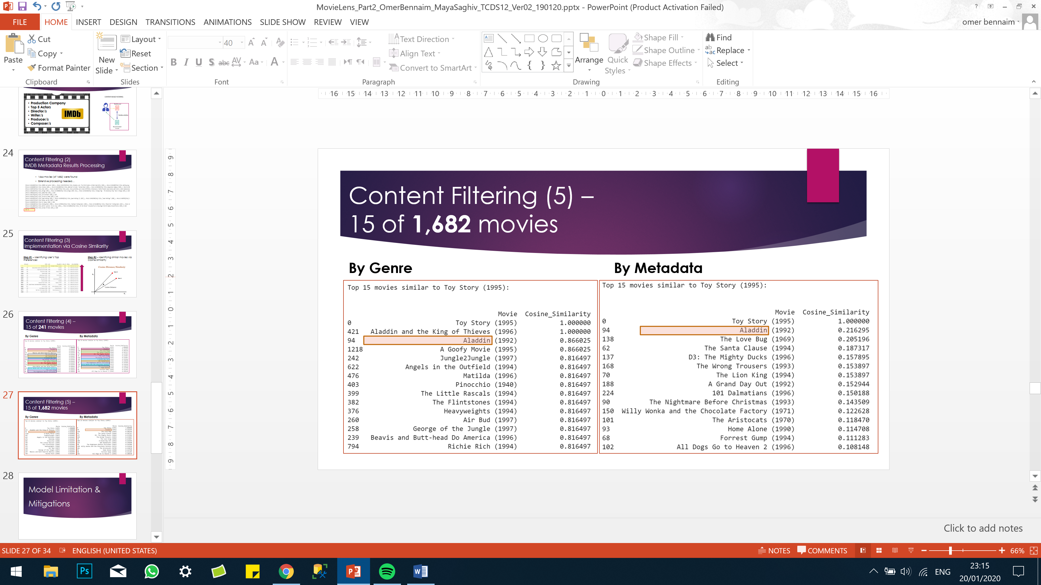

As it can be seen, the lists are completely different. It can also be seen that the two metadata’s lists (all movies and 241 movies) are the same, while the genres’ lists were changed. Why so? Probably because of the fact that the genre vector alone is too short and makes the system unstable when new movies are added. While the full metadata vector contain more items and it more robust for changes will new movies are added in.

### **Conclusions**

Content-based filtering is a good method to find similar movies to a specific movie. The collected content as a crucial role to recommend the right items. It is not means “The more - The better” because too much information can leads to high divergence which makes the similarity rate drop.

## **Model Limitations & Mitigations**

### **Model Weaknesses & Limitations**

* High Variance of Data (diverse movies / users / ratings).
* Unbalanced Data (‘Popular Items’ vs. ‘Niche’).
* Absence of ‘Ground Truth’ (cases of predicted rating with no ‘Actual’ User-Rating).
* New Users / Movies (on whom / which there is very few data).
* ‘Eccentric’ Movies (extremely liked by certain users and extremely disliked by others) – are more complex for the Recommendation System to generate recommendations for then 'non-eccentric' movies.
* Equivocal Definition of Thresholds for ‘Valuable’ Data (Rating>=5? 20? 50? 100?).
* Absence of ‘Holistic Evaluation Scenario’ – rating is 'subjective', and there is constantly some 'missing' information (e.g. actual movie ratings) - all keeping the 'Scenario' from being 'holistic' and making it more difficult to evaluate.

### **Mitigations to Model Weaknesses & Limitations**

* ‘Cross Validation’ in Model Selection process – the 'Cross Validation' process assures each movie will be both used for 'training', as well as used for 'testing'. This mitigates a case where the 'training' data does not represent well the 'testing' data (which may occur in data with high-variance such as 'Movielens').
* Careful Selection of ‘Valuable’ Data (to achieve high-quality results) – carefully selecting Rating>=5 as input data to the model.
* ‘Risk Distribution’ – as data is with high variance, in order to prevent BIAS resulting from certain models / datasets, crosscheck is done between results of the following:
  + Several Paradigms of Recommendation Systems (collaborative, Content).
  + Several Models - Basic Algorithms, K-NN inspired, Matrix Factorization-based, Slope One, Co-Clustering.
  + Several Datasets per Model (Ratings>=1,>=5,>=20,>=50 >=100).
  + Several Performance Measures (RMSE, MAE, ‘Hit-Rate’).

# **Conclusions**



## **The main conclusions from the project described above are as follows:**

* Data Relationship Understanding is essential for proper Data Pre-processing

(Example above: Movies ⬄ Ratings ⬄ Users)

* ‘Collaborative Filtering’ ‘Valuable Data’ Trade-Off - Data Integrity vs. ‘Long-Tail’ Leverage – Data Integrity may be higher as approaching the 'Head' of the distribution, however by filtering only that part of the data the less opportunities are left to leverage the 'Long Tail'
* ‘Content Based’ Positive Correlation between Sample Size & Quality of Recommendations – as seen above, the greater the sample size, the higher the quality of the 'Content-based' recommendation
* Contribution of Embedding External Data (IMDb) – embedding the IMDb content to 'Genres' significantly improved the quality of the 'Content-Based' recommendation
* ‘Risk Distribution’ for Variance Reduction using inputs from various models - recommendation system paradigms / models / datasets (see 3rd bullet under 'Mitigations to Model Weaknesses & Limitations' above)
* ‘Recommendation Systems’ produce best results for ‘Mainstream’ (non-eccentric) users / items (see 5th bullet under 'Model Weaknesses & Limitations' above)
* Best Model for ‘MovieLens’ dataset: KNNBaseline | CV=10

Performance Measures: ‘RMSE’: 0.93 ; ‘MAE’: 0.73 ; ‘Hit Rate’: 0.6

(as seen under 'Collaborative Filtering Best Model Selection' above)

# **Future Work**

* **Advanced Content Filtering** (e.g. ‘Storyline’ Text Mining to measure similarities between movies)
* **Demographic (Segmentation)** based Recommendations System – relevant to new users (on whom there is not much data)
* **‘Hybrid’ Recommendation Models** (e.g. ‘Content’ + ‘Collaborative’)
* **Advanced User-Labeling & Movie Segmentation** (Providing **‘**Top’ recommendations for each User-Label)
* Methods & Techniques (for such User-Labeling / Movie Segmentation):
  + **T-SNE** (t-distributed stochastic neighbor embedding) / Unsupervised Learning

A dimensionality reduction technique suited for visualizing high-dimensional data in a low-dimensional space

<https://www.datacamp.com/community/tutorials/introduction-t-sne>

* + **GNN** (Graph Neural Networks) / Semi-Supervised Learning

Directed Graph containing embedded information (e.g. regarding relationships)

<https://www.quora.com/What-are-Graph-Neural-Networks-GNN-in-AI-and-Machine-Learning-ML>

# **Appendices**

## Appendix 1

'Collaborative Filtering' Results of each Run:

